**DAILY ONLINE ACTIVITIES SUMMARY**

|  |  |  |  |  |  |  |  |  |
| --- | --- | --- | --- | --- | --- | --- | --- | --- |
| **Date:** | **26-06-2020** | | | | | **Name:** | **Shiza Amreen.J** | |
| **Sem & Sec** | **4th Sem B Sec** | | | | | **USN:** | **4AL18CS078** | |
| **Online Test Summary** | | | | | | | | |
| **Subject** | | **--** | | | | | | |
| **Max. Marks** | | **--** | | **Score** | | | **--** | |
| **Certification Course Summary** | | | | | | | | |
| **Course** | **Introduction to R** | | | | | | | |
| **Certificate Provider** | | | **GreatLearning** | | **Duration** | | | **3 Hours** |
| **Coding Challenges** | | | | | | | | |
| **Problem Statement:** [**Given start and end of a range, write a Python program to print all negative numbers in given range.**](https://github.com/orgs/alvas-education-foundation/teams/2nd-year/discussions/137) | | | | | | | | |
| **Status: Completed** | | | | | | | | |
| **Uploaded the report in Github** | | | | | **Yes** | | | |
| **If yes Repository name** | | | | | **Lockdown_coding**  <https://github.com/ShizaAmreen/Lockdown_coding> | | | |
| **Uploaded the report in slack** | | | | | **Yes** | | | |

Certification Course Details:

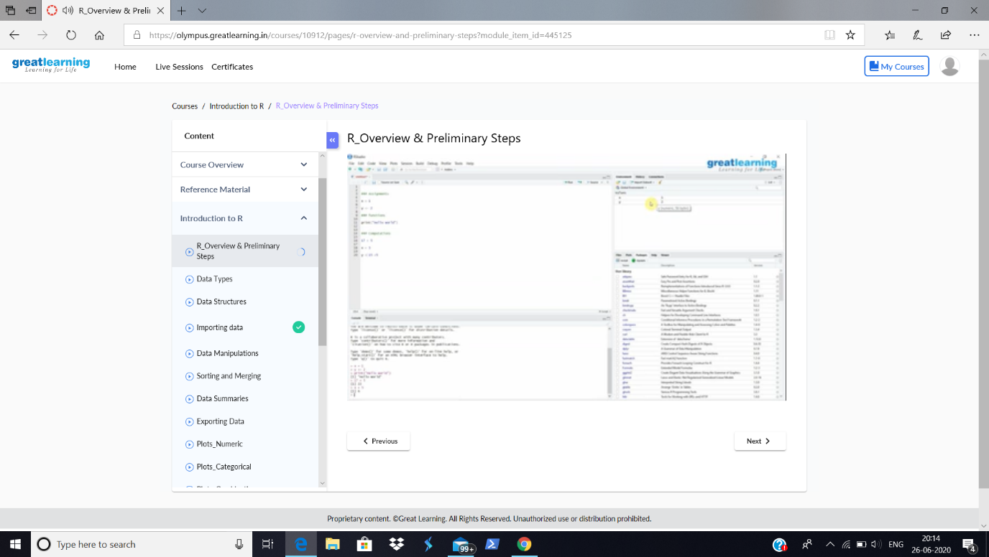

Today in the course, I have learnt about Overviews and Preliminary Steps of R.

Coding Challenges Details:

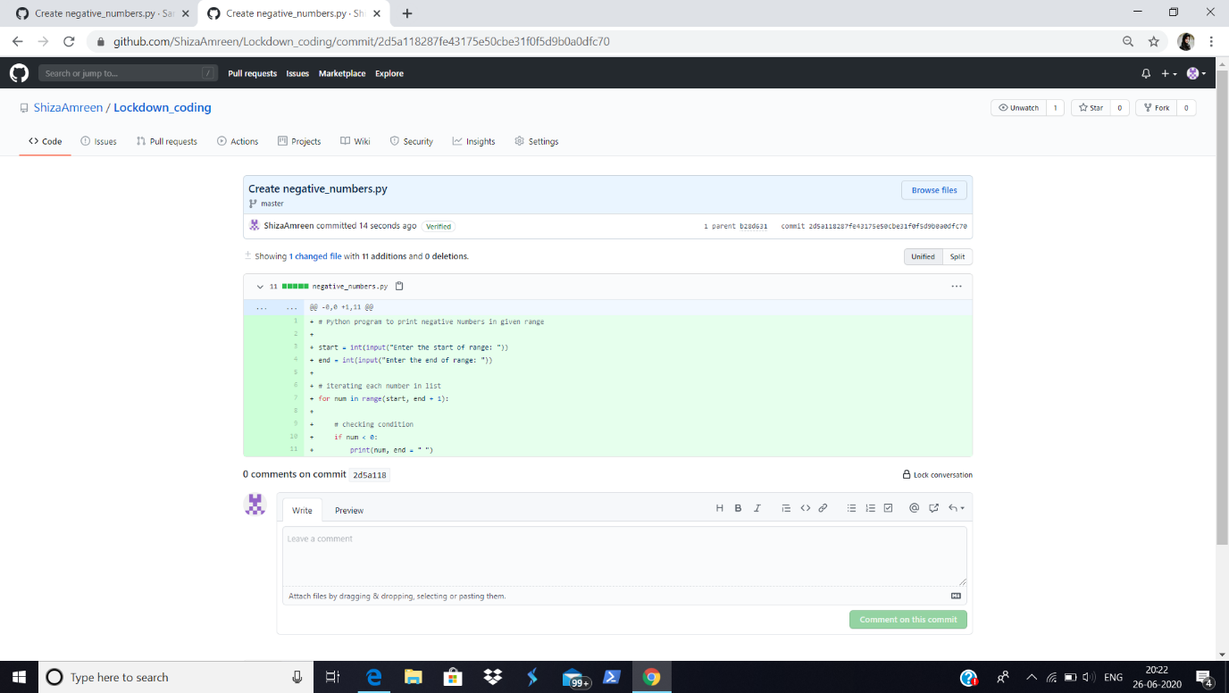

**I have written the code for given problem statement and uploaded it in my github repository, Lockdown_coding.**

<https://github.com/ShizaAmreen/Lockdown_coding/commit/2d5a118287fe43175e50cbe31f0f5d9b0a0dfc70>